- Answer: bstoll, btun, splunk_access, web_admin
The AWS documentation shows that the IAM user who performed an action is stored in the userIdentity.userName field when userIdentity.type="IAMUser"
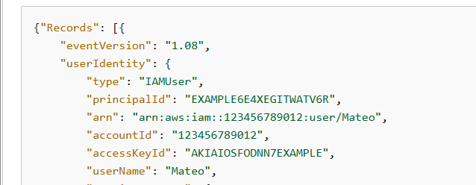

I then searched the BOTSv3 CloudTrail data using stats values() to get the distinct IAM user names:
index=botsv3 sourcetype="aws:cloudtrail"
| stats values(userIdentity.userName) AS iam_users
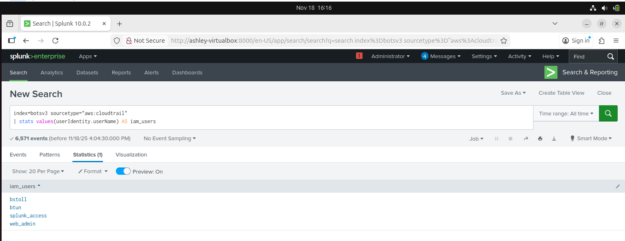

- Answer: userIdentity.sessionContext.attributes.mfaAuthenticated
I searched the BOTSv3 CloudTrail data for MFA-related API calls, excluding console logins as instructed:
index=botsv3 sourcetype="aws:cloudtrail" *mfa* NOT "ConsoleLogin"
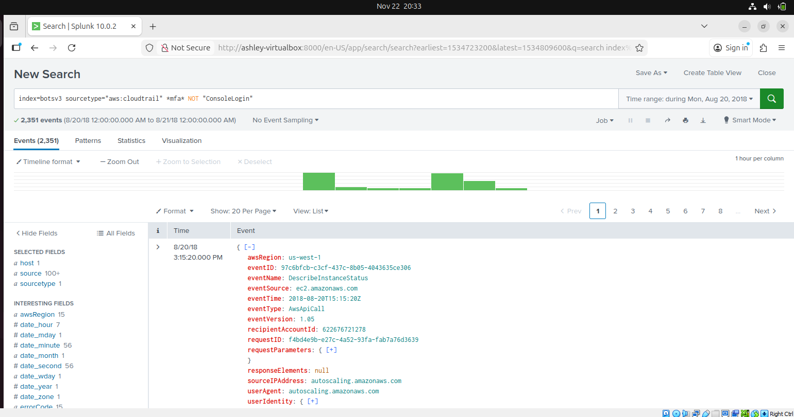
Then, in the Events view, I expanded userIdentity > sessionContext > attributes and saw the field mfaAuthenticated, which shows whether MFA was used with true/false.
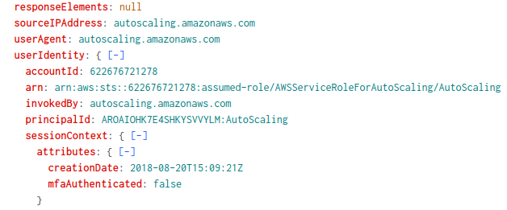
I then displayed this field in a table to get the exact JSON path:
index=botsv3 sourcetype="aws:cloudtrail" *mfa* NOT "ConsoleLogin"
| table userIdentity.sessionContext.attributes.mfaAuthenticated, eventName, userIdentity.userName
From the first column name, I confirmed the field to alert on AWS API activity without MFA.
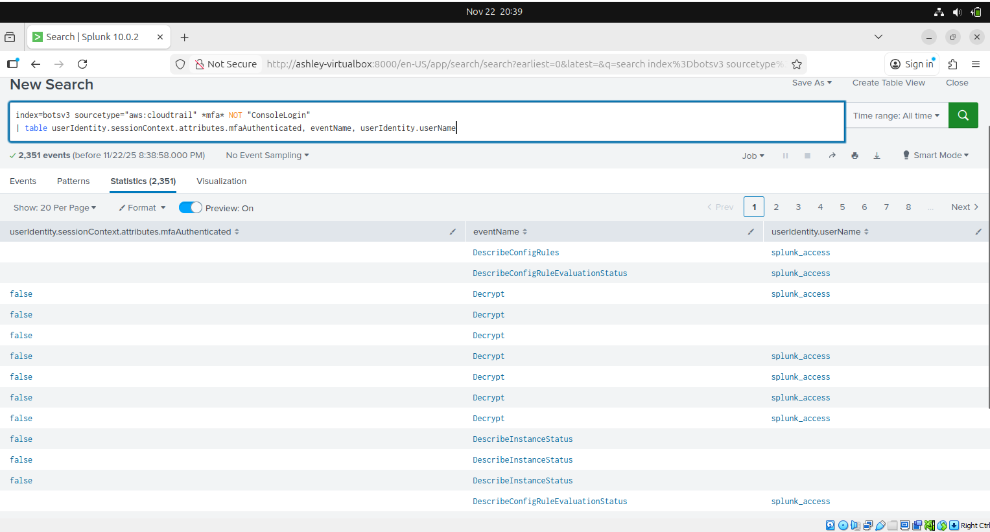

- Answer: E5-2676
Used the botsV3 data and “hardware” as the source type for the search
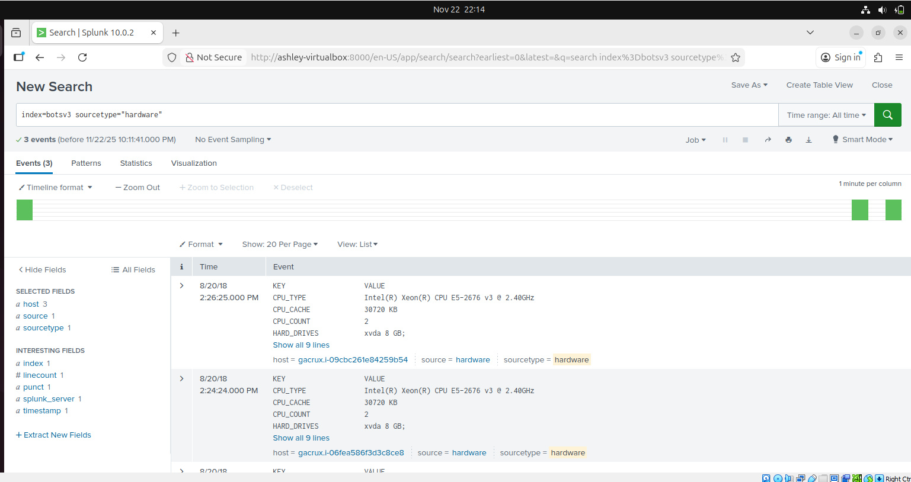

A closer look at the first displayed event showed the processor number used on the web servers.
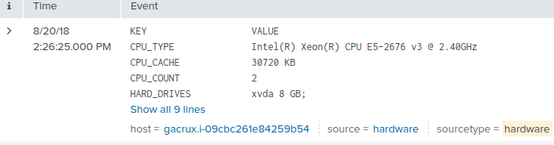

To confirm that the host hosts web servers, I used the search filter below and the results (Using stream:http and has the server: Apache/2.2.34 (Amazon)) confirmed it does:
index=botsv3 host="gacrux.i-09cbc261e84259b54"
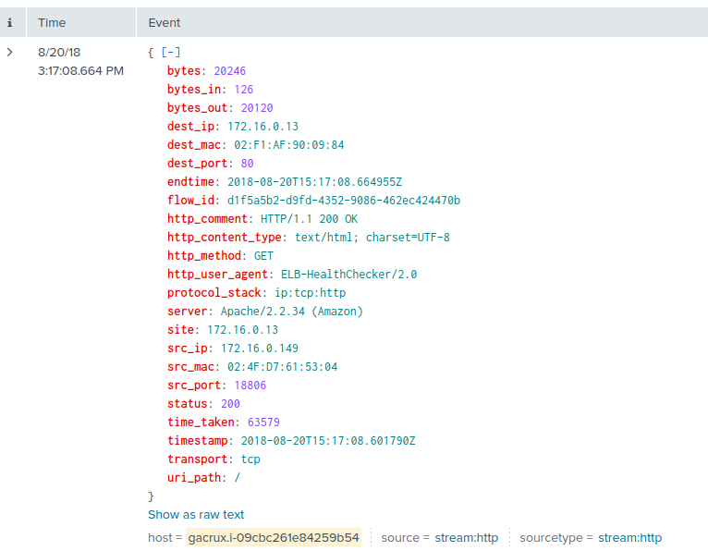

- Answer: ab45689d-69cd-41e7-8705-5350402cf7ac
To find the event ID, I searched for events with the name “PutBucketAcl” and this returned two events
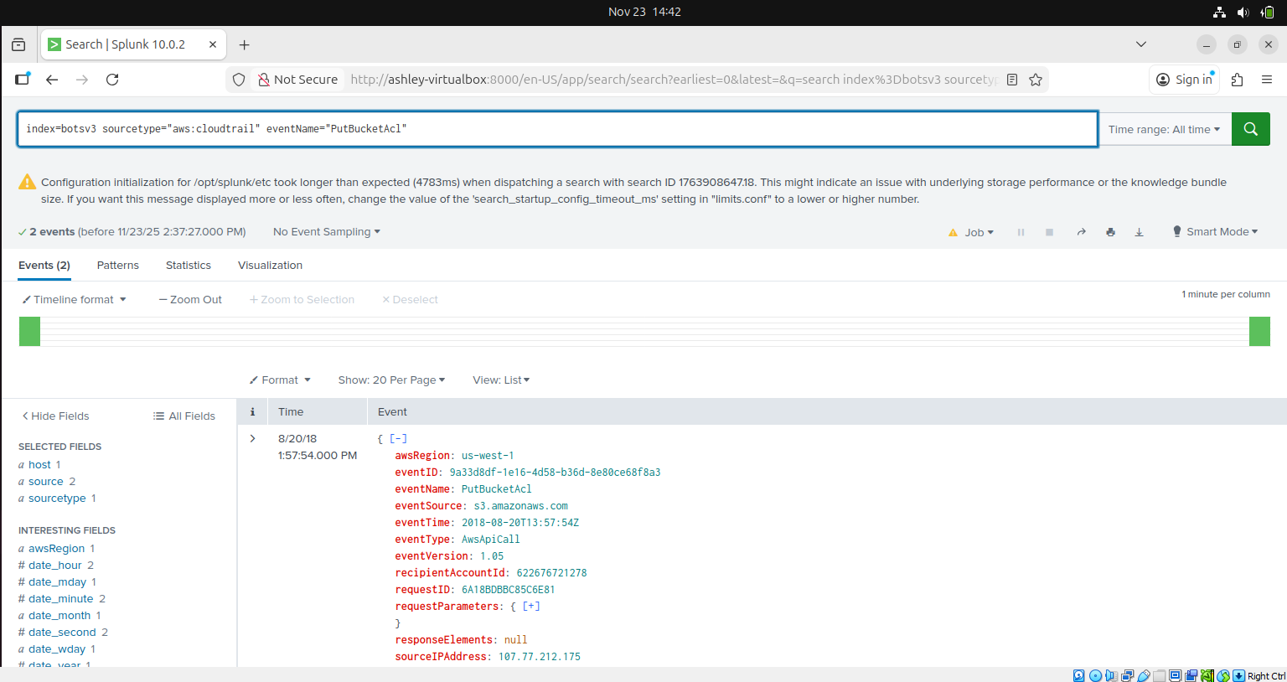

So to narrow it down to the event ID of the API call that gave access to all users. I used this search filter:
index=botsv3 sourcetype=”aws:cloudtrail” eventName=”PutBucketAcl” AllUsers
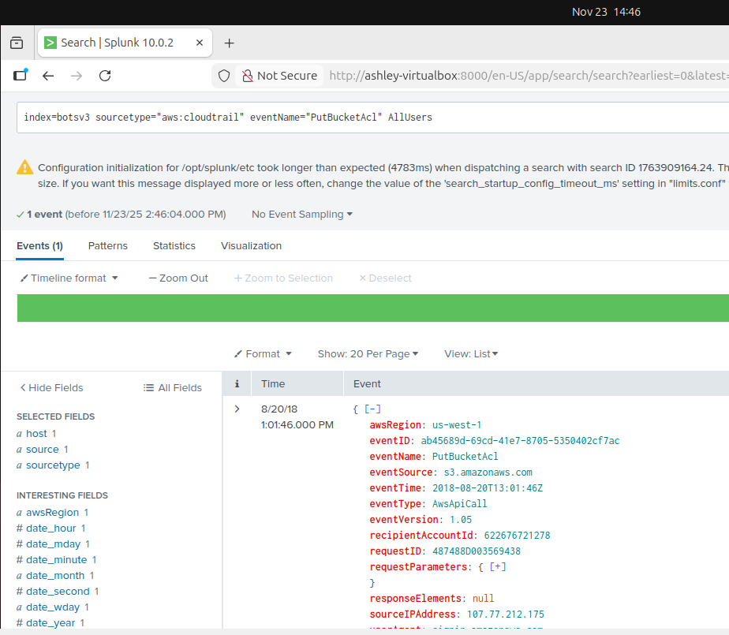

- Answer: bstoll
Expansion of the userIdentity from the event in the previous question revealed Bud’s username.
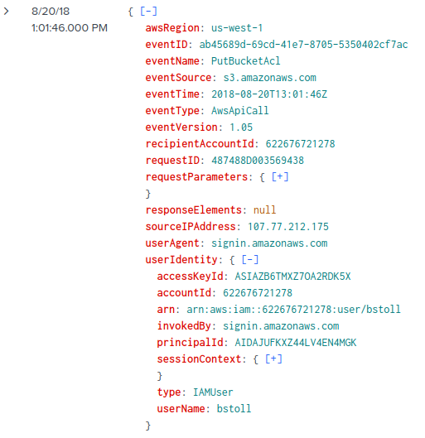
- Answer: frothlywebcode
Expansion of the requestParameters of the event in question 4 revealed the name of the S3 bucket that was made publicly accessible.
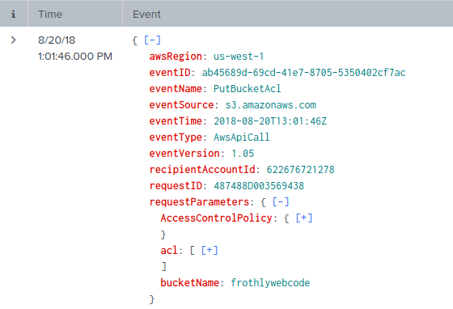

- Answer: OPEN_BUCKET_PLEASE_FIX.txt
I applied the filter below with the S3 bucket name included
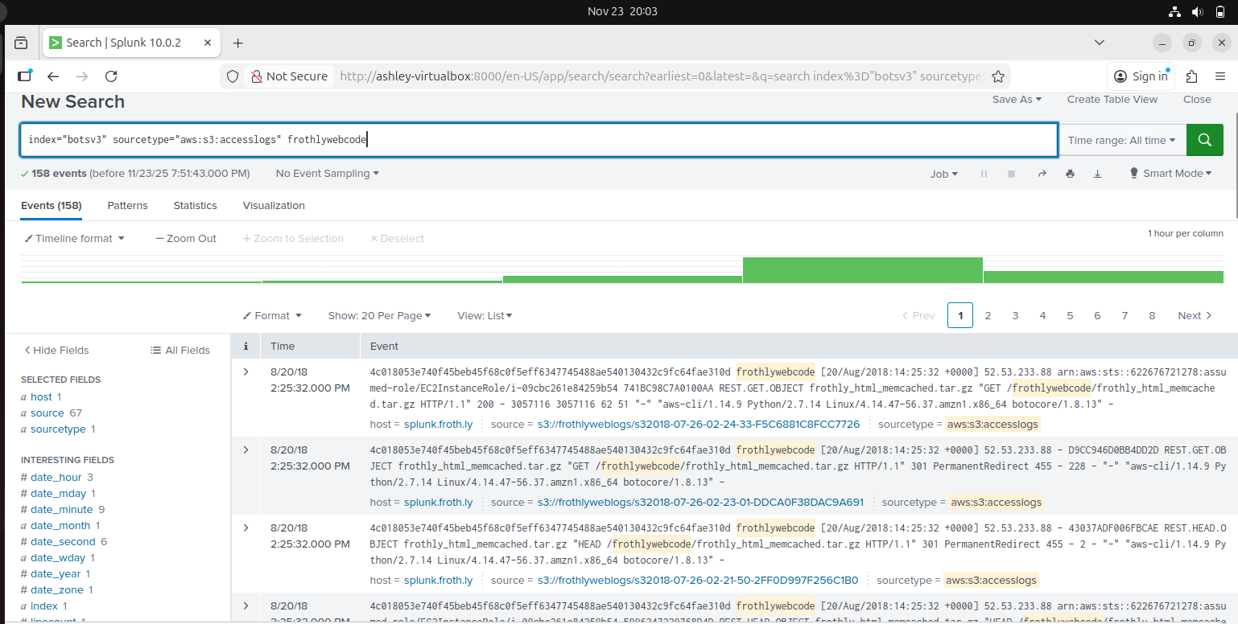

I noticed that the events in the picture above all had request parameters e.g. GET, HEAD, PUT etc. so to isolate the PutObject requests I applied this filter, and it narrowed it down to four events:
index="botsv3" sourcetype="aws:s3:accesslogs" frothlywebcode "REST.PUT.OBJECT"
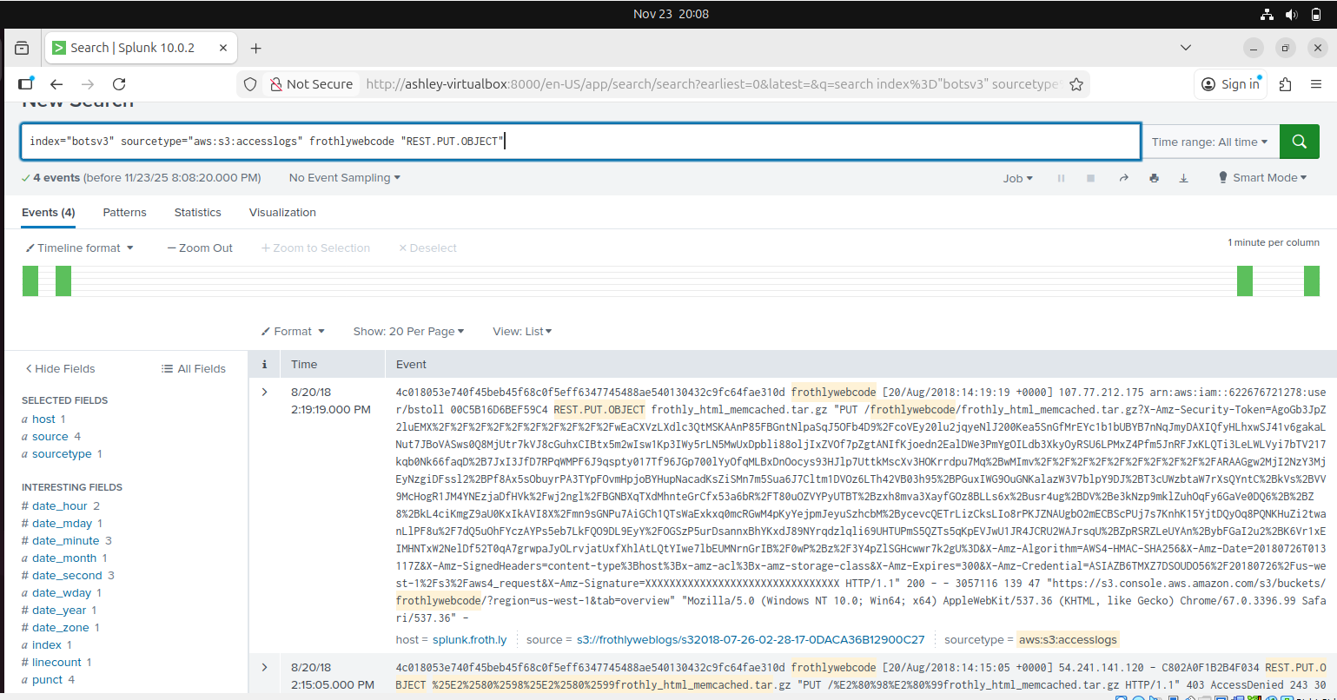

To find the .txt object, I applied this filter:
index="botsv3" sourcetype="aws:s3:accesslogs" frothlywebcode "REST.PUT.OBJECT" .txt
